
‘O’ Level
Project report
- Topic of Report –
Design and Development of a
Responsive Website for my Institute

Thank You
- Submitted By –
Name – Devansh Umar
Father’s Name – Mr. Awadhesh Kumar
Course – ‘O’Level (IT)
Reg. No. – 1602909
Mob. No. – 9696575301

Objective of the Project –
The main objective of this project is to create a website for Globus College of IT Management to apply the web designing concepts learned during the NIELIT O-Level course. The project includes different sections like academics, facilities, testimonials, and an online quiz section to make the website more interactive and useful for users.

Technologies Used –
The following technologies and tools were used during the development of this project:
- HTML5 – used to create the structure and content of web pages including text, images, tables, and navigation menus.
- CSS3 – used to enhance the visual appearance of the website by applying colours, layouts, fonts, spacing, and responsive design techniques.
- JavaScript – used to add interactivity and dynamic functionality such as online quizzes, timers, score calculation, certificate generation, and user interaction handling.
- W3.CSS Framework – used to simplify responsive design and provide pre-built styling components.
- GitHub – used for project hosting, documentation management, and source code storage.
- GitHub Pages – used to deploy and host the website online, making it publicly accessible through a web browser.
Project visual explanation

Link to Visit Web

{Double Click to Open}

{Globus College of IT and Management}

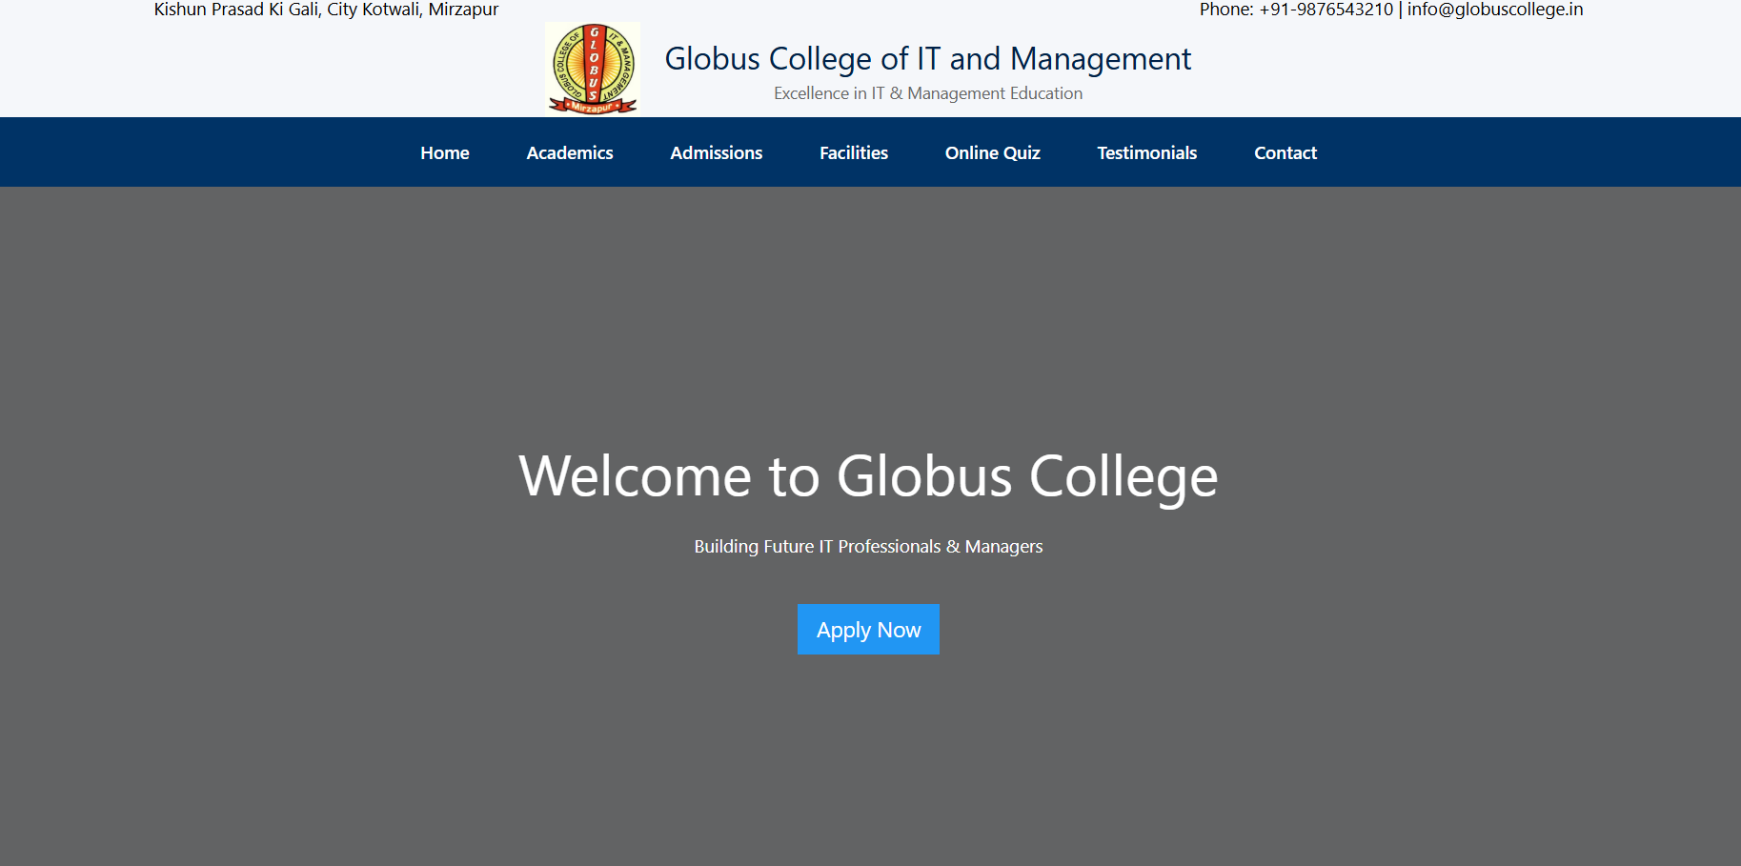
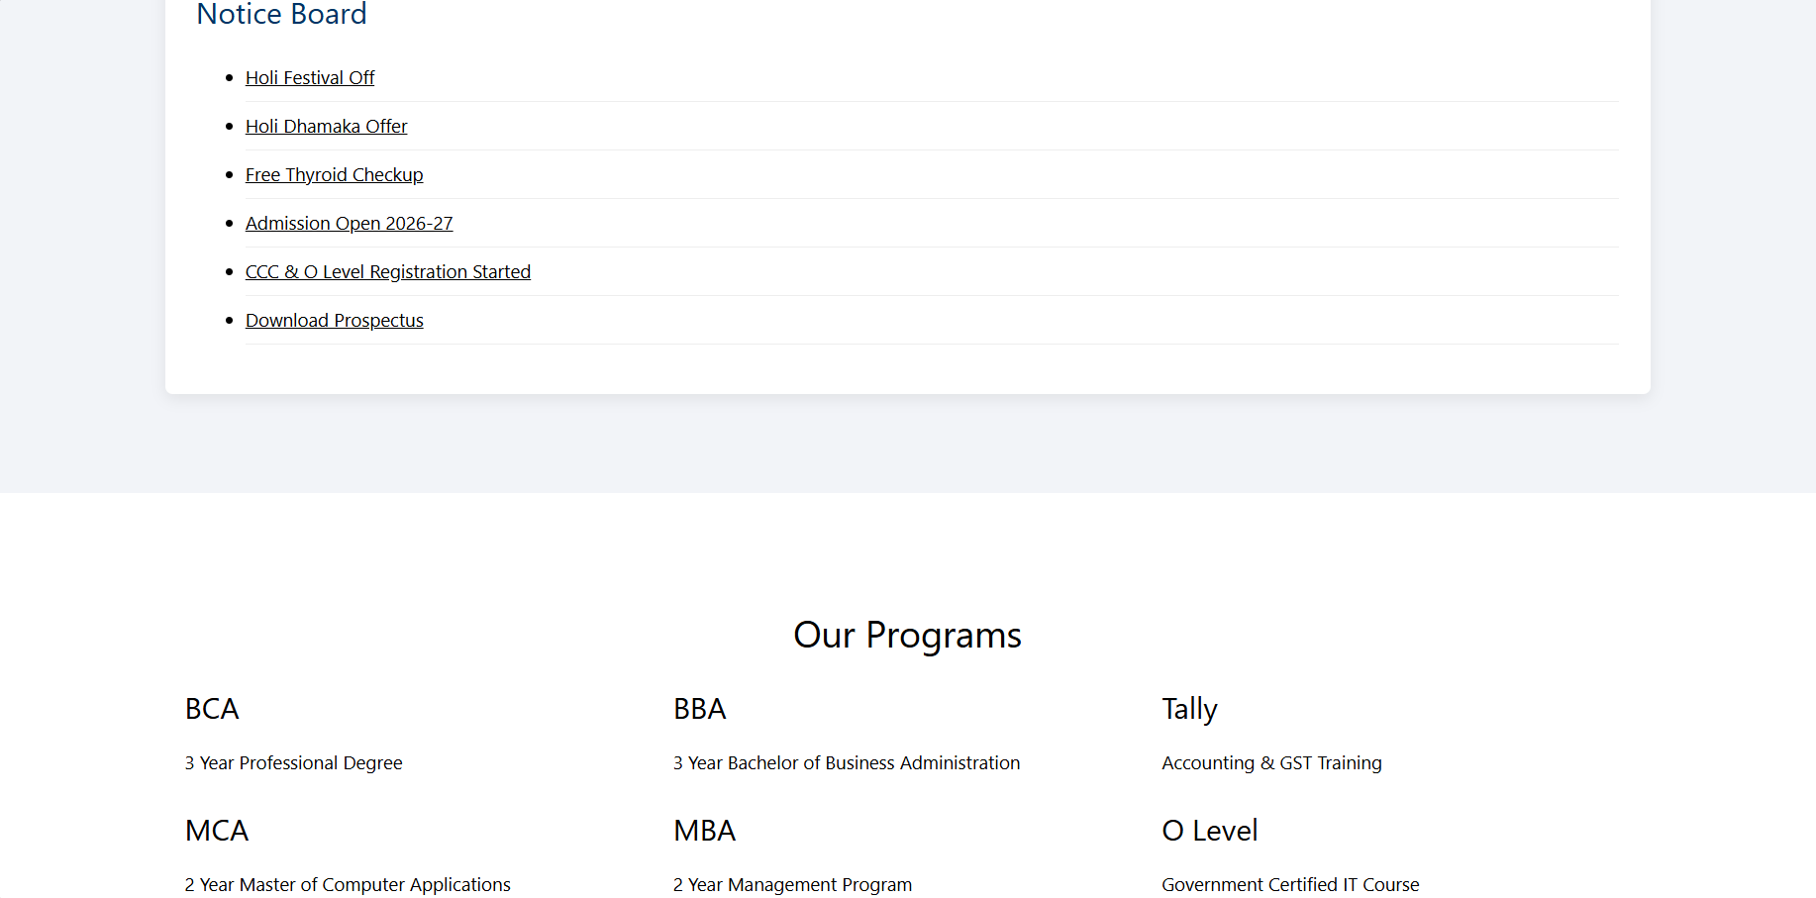
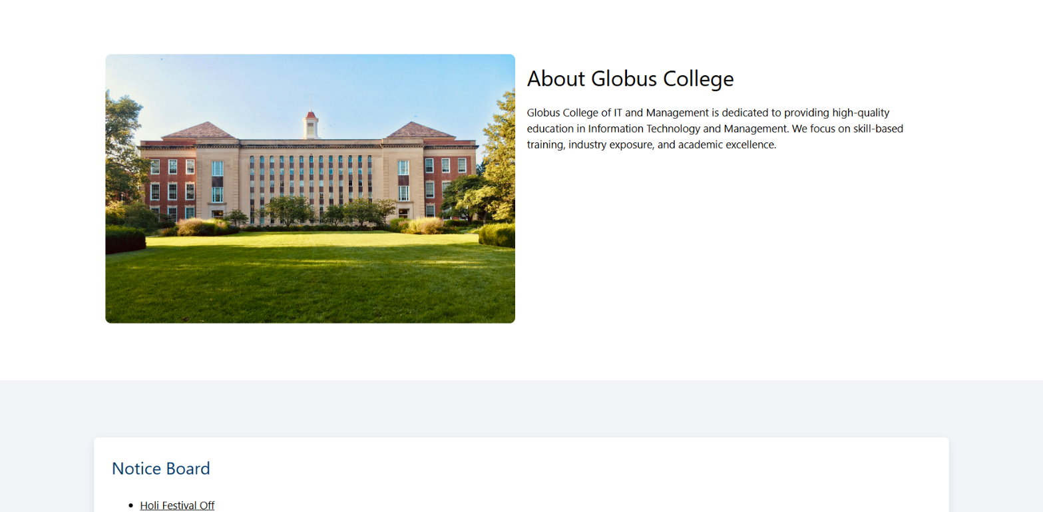
Home Page
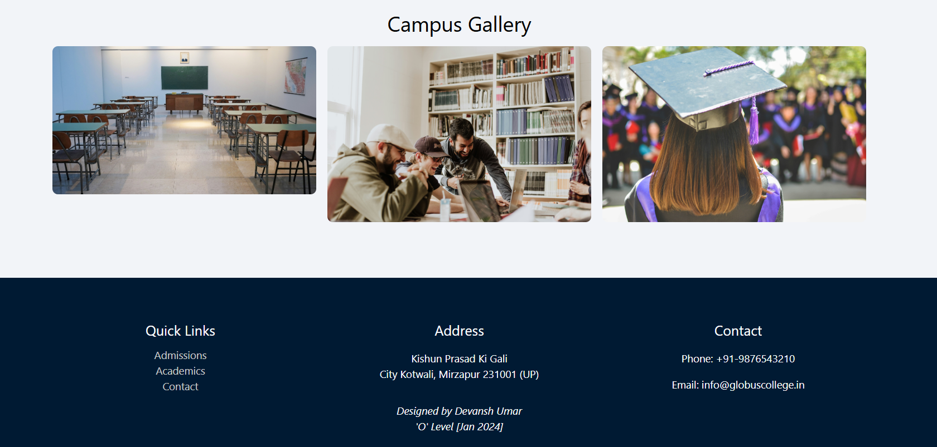

HTML CODE

<!DOCTYPE html>
<html>
<head>
<title>Globus College of IT and Management</title>
<link rel="stylesheet" href="https://www.w3schools.com/w3css/4/w3.css">
<link rel="stylesheet" href="style.css">
<script src="main.js" defer></script>
</head>
<body>
<!-- TOP BAR -->
<div class="top-bar">
<div class="container">
<div>Kishun Prasad Ki Gali, City Kotwali, Mirzapur</div>
<div>Phone: +91-9876543210 | info@globuscollege.in</div>
</div>
</div>
<!-- HEADER -->
<div class="header">
<div class="header-inner">
<a href="index.html">
<img src="logo.png" class="logo">
</a>
<div class="title-block">
<h1>Globus College of IT and Management</h1>
<p>Excellence in IT & Management Education</p>
</div>
</div>
</div>
<!-- NAVBAR -->
<div class="navbar">
<div class="nav-inner">
<a href="index.html">Home</a>
<a href="academics.html">Academics</a>
<a href="admissions.html">Admissions</a>
<a href="facilities.html">Facilities</a>
<a href="quiz.html">Online Quiz</a>
<a href="testimonials.html">Testimonials</a>
<a href="contact.html">Contact</a>
</div>
</div>
<!-- HERO SECTION -->
<section class="hero">
<div class="container">
<h1>Welcome to Globus College</h1>
<p>Building Future IT Professionals & Managers</p>
<br>
<a href="admissions.html" class="w3-button w3-blue w3-large">Apply Now</a>
</div>
</section>
<!-- ABOUT SECTION -->
<section class="section white-section">
<div class="container w3-row-padding">
<div class="w3-half">
<img src="https://images.unsplash.com/photo-1562774053-701939374585"
style="width:100%; border-radius:8px;">
</div>
<div class="w3-half">
<h2>About Globus College</h2>
<p>
Globus College of IT and Management is dedicated to providing
high-quality education in Information Technology and Management.
We focus on skill-based training, industry exposure, and
academic excellence.
</p>
</div>
</div>
</section>
<!-- NOTICE SECTION -->
<section class="section grey-section">
<div class="container">
<div class="notice-box">
<h3>Notice Board</h3>
<ul>
<li><a href = "Notice1.png" >Holi Festival Off</a></li>
<li><a href = "Notice2.jpeg" >Holi Dhamaka Offer</a></li>
<li><a href = "Notice3.jpeg" >Free Thyroid Checkup</a></li>
<li><a href = "#">Admission Open 2026-27</a></li>
<li><a href = "#">CCC & O Level Registration Started</a></li>
<li><a href = "#">Download Prospectus</a></li>
</ul>
</div>
</div>
</section>
<!-- PROGRAMS SECTION -->
<section class="section white-section">
<div class="container">
<h2 style="text-align:center;">Our Programs</h2>
<div class="w3-row-padding">
<div class="w3-third">
<div class="program-card">
<h3>BCA</h3>
<p>3 Year Professional Degree</p>
</div>
</div>
<div class="w3-third">
<div class="program-card">
<h3>BBA</h3>
<p>3 Year Bachelor of Business Administration</p>
</div>
</div>
<div class="w3-third">
<div class="program-card">
<h3>Tally</h3>
<p>Accounting & GST Training</p>
</div>
</div>
<div class="w3-third">
<div class="program-card">
<h3>MCA</h3>
<p>2 Year Master of Computer Applications</p>
</div>
</div>
<div class="w3-third">
<div class="program-card">
<h3>MBA</h3>
<p>2 Year Management Program</p>
</div>
</div>
<div class="w3-third">
<div class="program-card">
<h3>O Level</h3>
<p>Government Certified IT Course</p>
</div>
</div>
</div>
</div>
</section>
<!-- GALLERY SECTION -->
<section class="section grey-section">
<div class="container">
<h2 style="text-align:center;">Campus Gallery</h2>
<div class="w3-row-padding">
<div class="w3-third">
<img src="https://images.unsplash.com/photo-1580582932707-520aed937b7b"
style="width:100%; border-radius:8px;">
</div>
<div class="w3-third">
<img src="https://images.unsplash.com/photo-1523240795612-9a054b0db644"
style="width:100%; border-radius:8px;">
</div>
<div class="w3-third">
<img src="https://images.unsplash.com/photo-1523580846011-d3a5bc25702b"
style="width:100%; border-radius:8px;">
</div>
</div>
</div>
</section>
<!-- FOOTER -->
<footer>
<div class="container">
<div class="w3-row">
<div class="w3-third">
<h4>Quick Links</h4>
<a href="admissions.html">Admissions</a><br>
<a href="academics.html">Academics</a><br>
<a href="contact.html">Contact</a>
</div>
<div class="w3-third">
<h4>Address</h4>
<p>Kishun Prasad Ki Gali<br>
City Kotwali, Mirzapur 231001 (UP)</p>
</div>
<div class="w3-third">
<h4>Contact</h4>
<p>Phone: +91-9876543210</p>
<p>Email: info@globuscollege.in</p>
</div>
</div>
<div><i>Designed by Devansh Umar<br>
'O' Level [Jan 2024]</i></div>
</div>
</footer>
</body>
</html>
Academics page

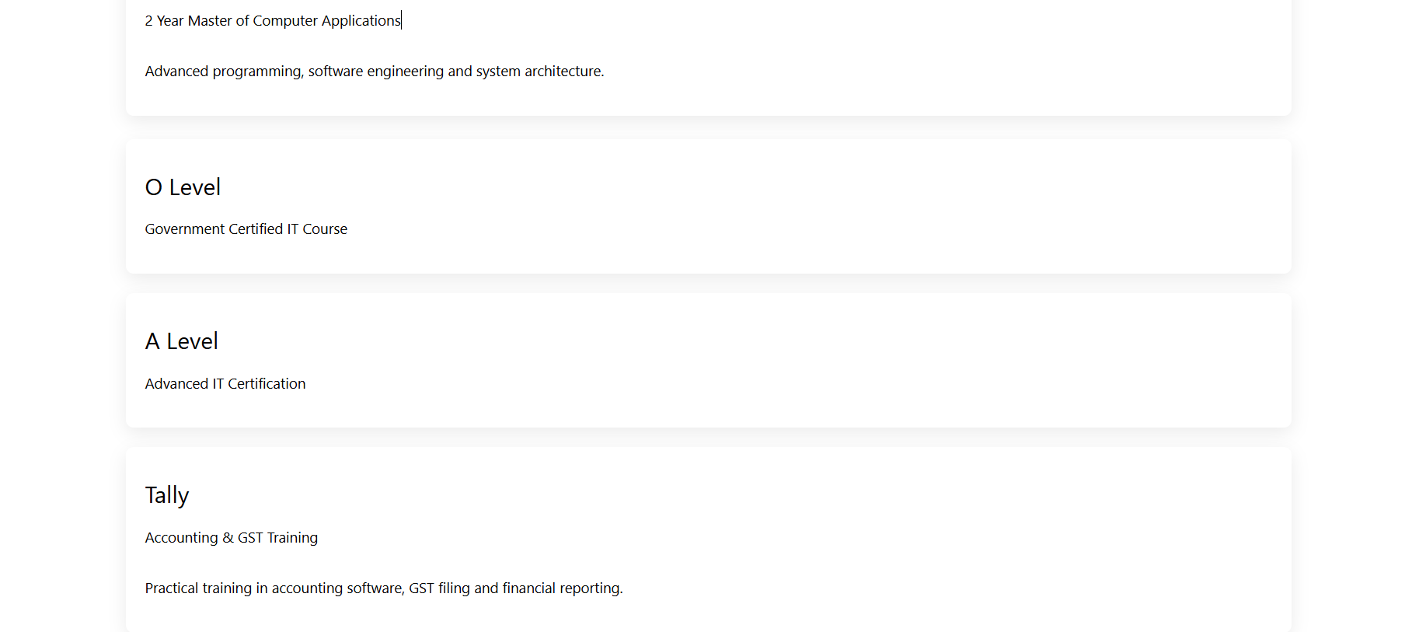
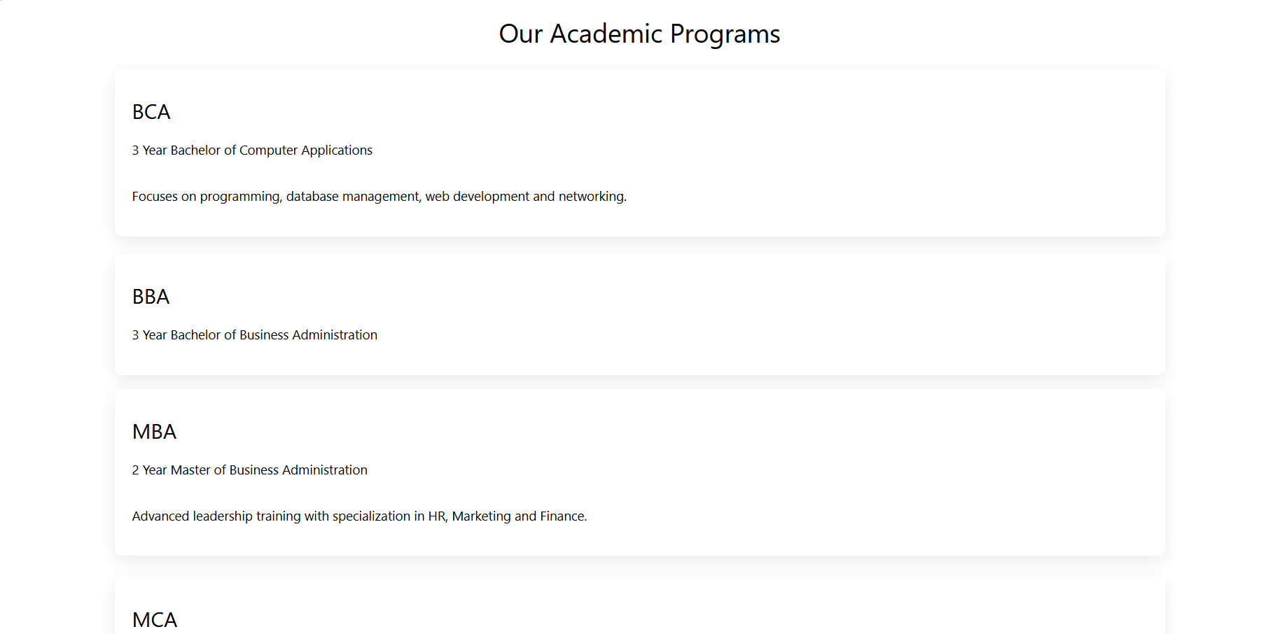
HTML CODE

<!DOCTYPE html>
<html>
<head>
<title>Programs - Globus College</title>
<link rel="stylesheet" href="https://www.w3schools.com/w3css/4/w3.css">
<link rel="stylesheet" href="style.css">
<script src="main.js" defer></script>
</head>
<body>
<section class="section white-section">
<div class="container">
<h2 style="text-align:center;">Our Academic Programs</h2>
<!-- BCA -->
<div class="program-box" onclick="toggleProgram(this)">
<div class="program-header">
<h3>BCA</h3>
<p>3 Year Bachelor of Computer Applications</p>
</div>
<div class="program-content">
<p>Focuses on programming, database management, web development and networking.</p>
</div>
</div>
<!-- BBA -->
<div class="program-box" onclick="toggleProgram(this)">
<div class="program-header">
<h3>BBA</h3>
<p>3 Year Bachelor of Business Administration</p>
</div>
<div class="program-content">
<p>Develops management, marketing, finance and entrepreneurship skills.</p>
</div>
</div>
<!-- MBA -->
<div class="program-box" onclick="toggleProgram(this)">
<div class="program-header">
<h3>MBA</h3>
<p>2 Year Master of Business Administration</p>
</div>
<div class="program-content">
<p>Advanced leadership training with specialization in HR, Marketing and Finance.</p>
</div>
</div>
<!-- MCA -->
<div class="program-box" onclick="toggleProgram(this)">
<div class="program-header">
<h3>MCA</h3>
<p>2 Year Master of Computer Applications</p>
</div>
<div class="program-content">
<p>Advanced programming, software engineering and system architecture.</p>
</div>
</div>

<!-- O Level -->
<div class="program-box" onclick="toggleProgram(this)">
<div class="program-header">
<h3>O Level</h3>
<p>Government Certified IT Course</p>
</div>
<div class="program-content">
<p>Foundation course in computer applications, internet and programming basics.</p>
</div>
</div>

<!-- A Level -->
<div class="program-box" onclick="toggleProgram(this)">
<div class="program-header">
<h3>A Level</h3>
<p>Advanced IT Certification</p>
</div>
<div class="program-content">
<p>Advanced level course covering software development and IT systems.</p>
</div>
</div>

<!-- Tally -->
<div class="program-box" onclick="toggleProgram(this)">
<div class="program-header">
<h3>Tally</h3>
<p>Accounting & GST Training</p>
</div>
<div class="program-content">
<p>Practical training in accounting software, GST filing and financial reporting.</p>
</div>
</div>

<!-- CCC -->
<div class="program-box" onclick="toggleProgram(this)">
<div class="program-header">
<h3>CCC</h3>
<p>Course on Computer Concepts</p>
</div>
<div class="program-content">
<p>Basic computer literacy course certified by government authorities.</p>
</div>
</div>

<!-- DCA -->
<div class="program-box" onclick="toggleProgram(this)">
<div class="program-header">
<h3>DCA</h3>
<p>Diploma in Computer Applications</p>
</div>
<div class="program-content">
<p>Diploma course covering MS Office, Internet and basic programming.</p>
</div>
</div>

<!-- ADCA -->
<div class="program-box" onclick="toggleProgram(this)">
<div class="program-header">
<h3>ADCA</h3>
<p>Advanced Diploma in Computer Applications</p>
</div>
<div class="program-content">
<p>Advanced computer diploma including web design and accounting software.</p>
</div>
</div>

<!-- PGDCA -->
<div class="program-box" onclick="toggleProgram(this)">
<div class="program-header">
<h3>PGDCA</h3>
<p>Post Graduate Diploma in Computer Applications</p>
</div>
<div class="program-content">
<p>Postgraduate diploma focused on software development and IT management.</p>
</div>
</div>

<!-- Fashion Design -->
<div class="program-box" onclick="toggleProgram(this)">
<div class="program-header">
<h3>PG in Fashion Design</h3>
<p>Professional Fashion Designing Course</p>
</div>
<div class="program-content">
<p>Training in garment design, textile technology and fashion entrepreneurship.</p>
</div>
</div>
</div>
</section>

<footer>
© 2026 Globus College
</footer>
</body>
</html>

Admission page

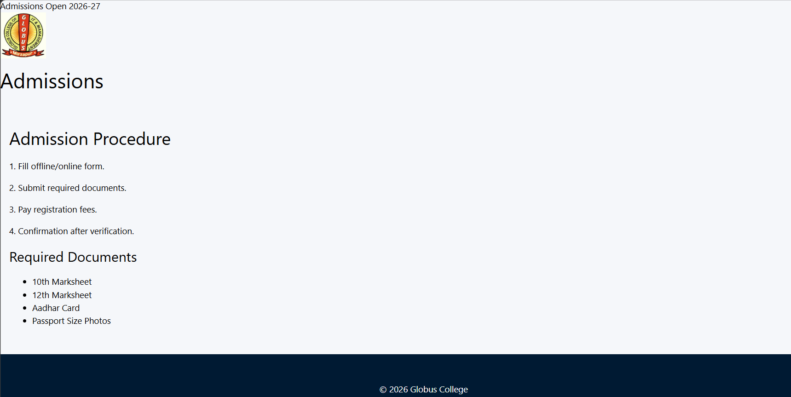

HTML CODE

<!DOCTYPE html>
<html>
<head>
<title>Admissions</title>
<link rel="stylesheet" href="https://www.w3schools.com/w3css/4/w3.css">
<link rel="stylesheet" href="style.css">
<script src="main.js" defer></script>
</head>
<body>
<div class="top-bar">
Admissions Open 2026-27
</div>
<div class="logo-section">
<a href="index.html">
<img src="logo.png" class="logo">
</a>
<div class="college-title">
<h1>Admissions</h1>
</div>
</div>
<div class="w3-container w3-padding-32">
<h2>Admission Procedure</h2>
<p>1. Fill offline/online form.</p>
<p>2. Submit required documents.</p>
<p>3. Pay registration fees.</p>
<p>4. Confirmation after verification.</p>
<h3>Required Documents</h3>
<ul>
<li>10th Marksheet</li>
<li>12th Marksheet</li>
<li>Aadhar Card</li>
<li>Passport Size Photos</li>
</ul>
</div>
<footer>
© 2026 Globus College
</footer>
</body>
</html>
Facilities page

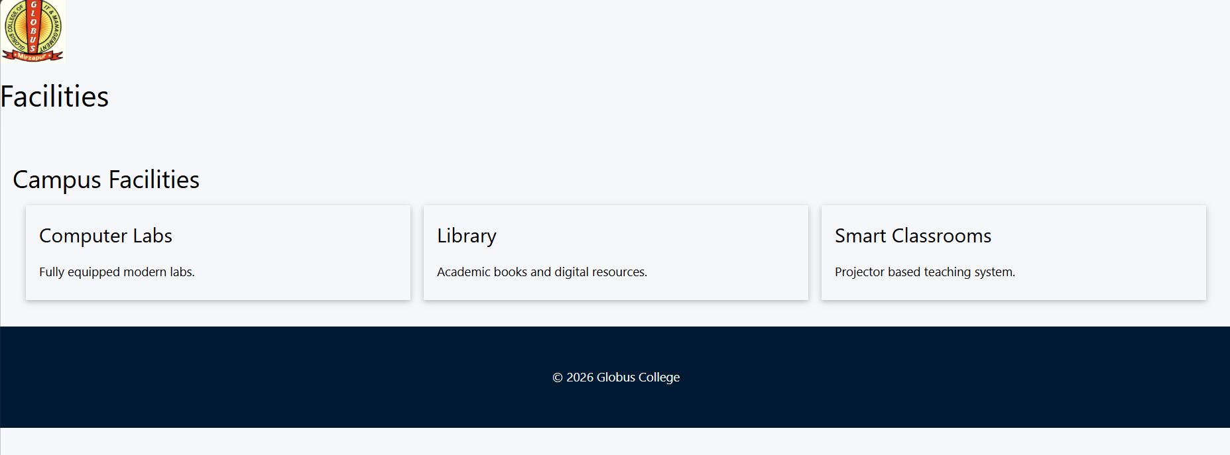

HTML CODE

<!DOCTYPE html>
<html>
<head>
<title>Facilities</title>
<link rel="stylesheet" href="https://www.w3schools.com/w3css/4/w3.css">
<link rel="stylesheet" href="style.css">
</head>
<body>
<div class="logo-section">
<a href="index.html">
<img src="logo.png" class="logo">
</a>
<div class="college-title">
<h1>Facilities</h1>
</div>
</div>
<div class="w3-container w3-padding-32">
<h2>Campus Facilities</h2>
<div class="w3-row-padding">
<div class="w3-third">
<div class="w3-card w3-padding">
<h3>Computer Labs</h3>
<p>Fully equipped modern labs.</p>
</div>
</div>
<div class="w3-third">
<div class="w3-card w3-padding">
<h3>Library</h3>
<p>Academic books and digital resources.</p>
</div>
</div>
<div class="w3-third">
<div class="w3-card w3-padding">
<h3>Smart Classrooms</h3>
<p>Projector based teaching system.</p>
</div>
</div>
</div>
</div>
<footer>
© 2026 Globus College
</footer>
</body>
</html>
Quiz page
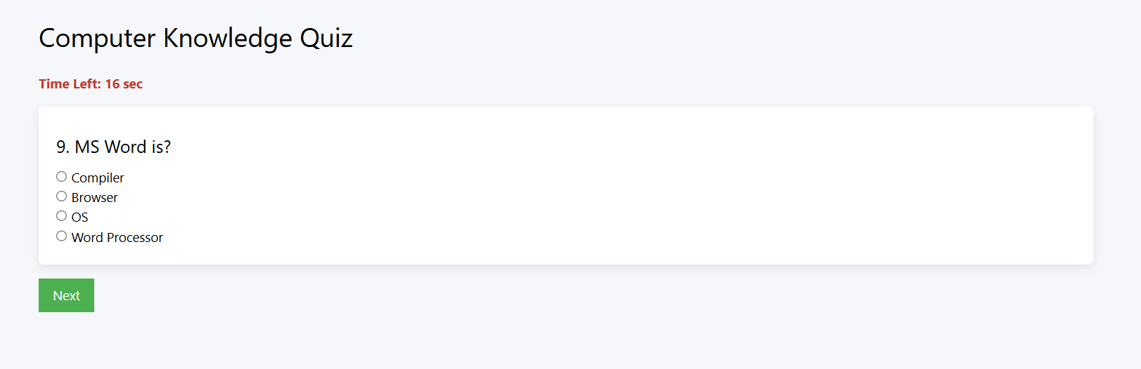

HTML CODE
<!DOCTYPE html>
<html>
<head>
<title>Online Quiz</title>
<link rel="stylesheet" href="https://www.w3schools.com/w3css/4/w3.css">
<link rel="stylesheet" href="style.css">
<script src="main.js" defer></script>
<script src="quiz.js" defer></script>
</head>
<body>
<div class="container" style="padding:40px 0;">
<h2>Computer Knowledge Quiz</h2>
<!-- Name Section -->
<div id="startSection">
<input class="w3-input w3-margin-bottom" type="text" id="studentName" placeholder="Enter Your Name">
<button class="w3-button w3-blue" onclick="startQuiz()">Start Quiz</button>
</div>
<!-- Quiz Section -->
<div id="quizSection" style="display:none;">
<div id="timer" style="font-weight:bold; margin-bottom:15px;"></div>
<div id="questionBox"></div>
<button class="w3-button w3-green w3-margin-top" onclick="nextQuestion()">Next</button>
</div>
<!-- Result Section -->
<div id="resultSection" style="display:none;">
<h3 id="scoreText"></h3>
<button class="w3-button w3-blue" onclick="generateCertificate()">Generate Certificate</button>
</div>
<!-- Certificate Section -->
<div id="certificateSection" class="certificate">
<div class="cert-border">
<img src="logo.png" class="cert-logo">
<h1>Certificate of Achievement</h1>
<p>This is proudly presented to</p>
<h2 id="certName"></h2>
<p>For successfully completing the</p>
<h3>Computer Knowledge Online Quiz</h3>
<p id="certScore"></p>
<p class="cert-date"></p>
<button class="w3-button w3-black" onclick="window.print()">Print Certificate</button>
</div>
</div>
</body>
</html>

JAVASCRIPT CODE
// Anti refresh check
if(sessionStorage.getItem("quizStarted") === "true"){
alert("Quiz was interrupted or page refreshed. Quiz will restart.");
sessionStorage.removeItem("quizStarted");
location.reload();
}
history.pushState(null, null, location.href);
window.onpopstate = function () {
history.go(1);
};
const questionBank = [
{q:"CPU stands for?",a:["Central Processing Unit","Computer Processing Unit","Central Program Unit","None"],correct:0},
{q:"RAM stands for?",a:["Random Access Memory","Read Access Memory","Run Access Memory","None"],correct:0},
{q:"Binary base is?",a:["2","8","10","16"],correct:0},
{q:"Shortcut for copy?",a:["Ctrl+C","Ctrl+V","Ctrl+X","Ctrl+Z"],correct:0},
{q:"HTML stands for?",a:["Hyper Text Markup Language","High Text Machine Language","Hyperlinks Text Mark","None"],correct:0},
{q:"CSS used for?",a:["Styling","Programming","Database","Networking"],correct:0},
{q:"Which is OS?",a:["Windows","Word","Excel","PowerPoint"],correct:0},
{q:"Input device?",a:["Keyboard","Monitor","Speaker","Printer"],correct:0},
{q:"WWW stands for?",a:["World Wide Web","Wide World Web","World Web Wide","None"],correct:0},
{q:"1 KB equals?",a:["1024 bytes","1000 bytes","512 bytes","2048 bytes"],correct:0},
{q:"Which is browser?",a:["Chrome","Windows","Linux","MS Word"],correct:0},
{q:"Excel is?",a:["Spreadsheet","Word Processor","OS","Browser"],correct:0},
{q:"Which is database?",a:["MySQL","HTML","CSS","CPU"],correct:0},
{q:"Monitor is?",a:["Output Device","Input Device","Storage","CPU"],correct:0},
{q:"USB is?",a:["Storage Interface","Software","OS","Language"],correct:0},
{q:"Shortcut for paste?",a:["Ctrl+V","Ctrl+C","Ctrl+X","Ctrl+Z"],correct:0},
{q:"MS Word is?",a:["Word Processor","OS","Browser","Compiler"],correct:0},
{q:"Which is storage device?",a:["Hard Disk","Mouse","Keyboard","Scanner"],correct:0},
{q:"Google is?",a:["Search Engine","OS","Software","Hardware"],correct:0},
{q:"IP stands for?",a:["Internet Protocol","Internal Program","Input Protocol","None"],correct:0}
];
let selectedQuestions = [];
let currentQuestion = 0;
let score = 0;
let timer;
let timeLeft = 20;
let studentName = "";
window.onbeforeunload = function () {
return true;
};
function startQuiz() {
studentName = document.getElementById("studentName").value;
if(studentName === "") {
alert("Please enter your name");
return;
}
selectedQuestions = questionBank.sort(() => 0.5 - Math.random()).slice(0, 10);
document.getElementById("startSection").style.display = "none";
document.getElementById("quizSection").style.display = "block";
loadQuestion();
function startQuiz() {
studentName = document.getElementById("studentName").value;
if(studentName === ""){
alert("Please enter your name");
return;
}
// mark quiz started
sessionStorage.setItem("quizStarted","true");
selectedQuestions = questionBank.sort(()=>0.5 - Math.random()).slice(0,10);
document.getElementById("startSection").style.display="none";
document.getElementById("quizSection").style.display="block";
loadQuestion();
}
}
function loadQuestion() {
if(currentQuestion >= selectedQuestions.length) {
finishQuiz();
return;
}
let q = selectedQuestions[currentQuestion];
// Shuffle options
let options = q.a.map((text, index) => ({text, index}));
options.sort(() => Math.random() - 0.5);
let optionsHTML = "";
options.forEach(opt => {
optionsHTML += `
<input type="radio" name="answer" value="${opt.index}">
${opt.text}<br>
`;
});
document.getElementById("questionBox").innerHTML = `
<h4>${currentQuestion+1}. ${q.q}</h4>
${optionsHTML}
`;
timeLeft = 20;
document.getElementById("timer").innerText = "Time Left: 20 sec";
timer = setInterval(() => {
timeLeft--;
document.getElementById("timer").innerText = "Time Left: " + timeLeft + " sec";
if(timeLeft <= 0) {
clearInterval(timer);
nextQuestion();
}
}, 1000);
}
function nextQuestion() {
clearInterval(timer);
let selected = document.querySelector('input[name="answer"]:checked');
if(selected && parseInt(selected.value) === selectedQuestions[currentQuestion].correct) {
score++;
}
currentQuestion++;
loadQuestion();
}
function finishQuiz() {
document.getElementById("quizSection").style.display = "none";
document.getElementById("resultSection").style.display = "block";
document.getElementById("scoreText").innerText =
"Your Score: " + score + " / 10";
function finishQuiz(){
sessionStorage.removeItem("quizStarted");
document.getElementById("quizSection").style.display="none";
document.getElementById("resultSection").style.display="block";
document.getElementById("scoreText").innerText =
"Your Score: " + score + " / 10";
}
}
function generateCertificate() {
document.getElementById("resultSection").style.display = "none";
document.getElementById("certificateSection").style.display = "block";
document.getElementById("certName").innerText = studentName;
document.getElementById("certScore").innerText =
"Score Achieved: " + score + " / 10";
document.querySelector(".cert-date").innerText =
"Date: " + new Date().toLocaleDateString();
}

Testimonial page

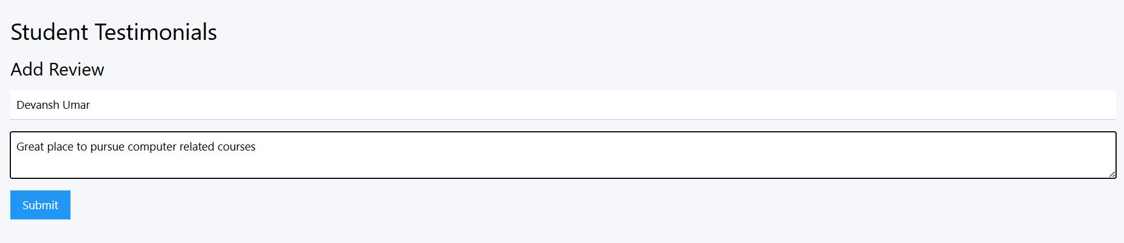

HTML CODE

<!DOCTYPE html>
<html>
<head>
<title>Testimonials</title>
<link rel="stylesheet" href="https://www.w3schools.com/w3css/4/w3.css">
<link rel="stylesheet" href="style.css">
<script src="main.js" defer></script>
</head>
<body>
<div class="w3-container w3-padding-32">
<h2>Student Testimonials</h2>
<div id="testimonialList"></div>
<h3>Add Review</h3>
<input class="w3-input w3-margin-bottom" type="text" id="name" placeholder="Your Name">
<textarea class="w3-input w3-margin-bottom" id="review" placeholder="Your Review"></textarea>
<button class="w3-button w3-blue" onclick="addTestimonial()">Submit</button>
</div>
</body>
</html>
contact page

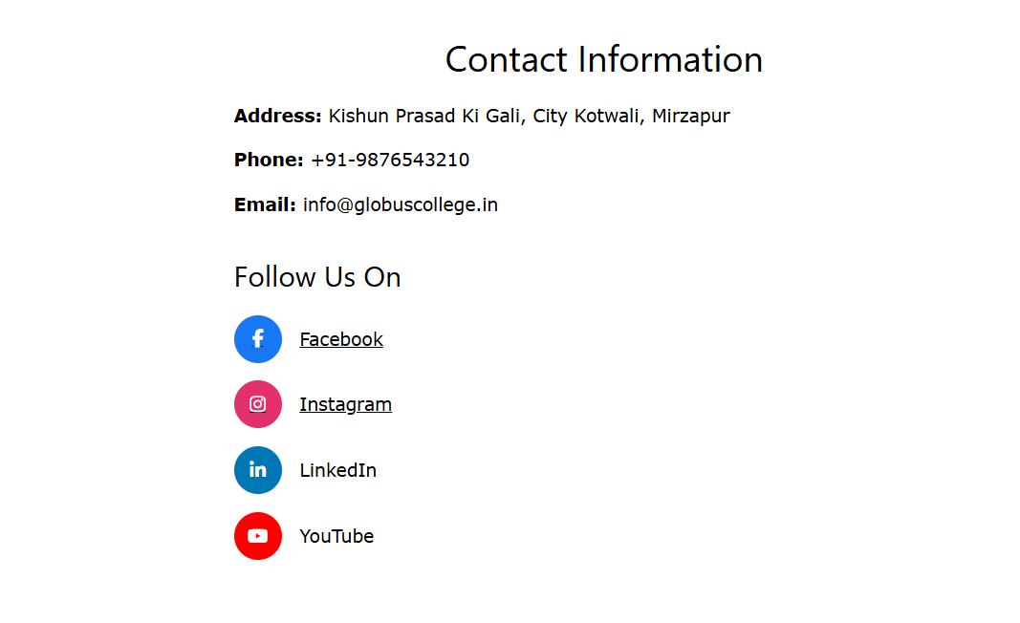
HTML CODE
<!DOCTYPE html>
<html>
<head>
<title>Contact Us</title>
<link rel="stylesheet" href="https://www.w3schools.com/w3css/4/w3.css">
<link rel="stylesheet" href="https://cdnjs.cloudflare.com/ajax/libs/font-awesome/6.5.0/css/all.min.css">
</head>
<body>
<div style="max-width:700px; margin:auto; padding:40px;">
<h2 style="text-align:center;">Contact Information</h2>
<p><b>Address:</b> Kishun Prasad Ki Gali, City Kotwali, Mirzapur</p>
<p><b>Phone:</b> +91-9876543210</p>
<p><b>Email:</b> info@globuscollege.in</p>
<h3 style="margin-top:30px;">Follow Us On</h3>
<!-- Facebook -->
<a href = "https://www.facebook.com/groups/Globus.world/"><div style="display:flex; align-items:center; margin:15px 0;">
<div style="width:40px; height:40px; border-radius:50%; background:#1877f2; display:flex; align-items:center; justify-content:center; color:white;">
<i class="fab fa-facebook-f"></i>
</div>
<span style="margin-left:15px; color:black;">Facebook</span>
</div>
</a>
<!-- Instagram -->
<a href = "https://www.instagram.com/globustechhub?igsh=MXBibG5ucWRrcGJlbQ=="><div style="display:flex; align-items:center; margin:15px 0;">
<div style="width:40px; height:40px; border-radius:50%; background:#e1306c; display:flex; align-items:center; justify-content:center; color:white;">
<i class="fab fa-instagram"></i>
</div>
<span style="margin-left:15px; color:black;">Instagram</span>
</div>
</a>
<!-- LinkedIn -->
<div style="display:flex; align-items:center; margin:15px 0;">
<div style="width:40px; height:40px; border-radius:50%; background:#0077b5; display:flex; align-items:center; justify-content:center; color:white;">
<i class="fab fa-linkedin-in"></i>
</div>
<span style="margin-left:15px; color:black;">LinkedIn</span>
</div>
<!-- YouTube -->
<div style="display:flex; align-items:center; margin:15px 0;">
<div style="width:40px; height:40px; border-radius:50%; background:#ff0000; display:flex; align-items:center; justify-content:center; color:white;">
<i class="fab fa-youtube"></i>
</div>
<span style="margin-left:15px; color:black;">YouTube</span>
</div>
</div>
</body>
</html>

CSS CODE (style.css)
body{
margin:0;
font-family:'Segoe UI', Arial, sans-serif;
background:#f5f7fa;
}
.container{
width:90%;
max-width:1200px;
margin:auto;
}
/* TOP BAR */
.top-bar{
background:#002147;
color:white;
font-size:14px;
padding:6px 0;
}
.top-bar .container{
display:flex;
justify-content:space-between;
}
/* HEADER */
.header{
background:white;
padding:20px 0;
border-bottom:1px solid #eee;
}
.header-inner{
max-width:1200px;
margin:auto;
display:flex;
align-items:center;
justify-content:center;
text-align:center;
}
.logo{
height:80px;
margin-right:20px;
}
.title-block h1{
margin:0;
font-size:26px;
color:#002147;
}
.title-block p{
margin:0;
font-size:14px;
color:#666;
}
/* NAVBAR */
.navbar{
width:100%;
background:#003366;
}
.nav-inner{
max-width:1200px;
margin:auto;
display:flex;
justify-content:center;
}
.nav-inner a{
color:white;
text-decoration:none;
padding:18px 24px;
display:block;
font-weight:500;
}
.nav-inner a:hover{
background:#0055aa;
}
/* HERO SECTION */
.hero{
background:linear-gradient(rgba(0,0,0,0.6),rgba(0,0,0,0.6)),
url('https://images.unsplash.com/photo-1523050854058-8df90110c9f1');
background-size:cover;
background-position:center;
height:80vh;
display:flex;
align-items:center;
justify-content:center;
text-align:center;
color:white;
}
.hero h1{
font-size:48px;
}
/* SECTIONS */
.section{
padding:80px 0;
}
.white-section{
background:white;
}
.grey-section{
background:#f2f4f8;
}
/* NOTICE BOARD */
.notice-box{
background:white;
padding:25px;
border-radius:6px;
box-shadow:0 4px 12px rgba(0,0,0,0.08);
}
.notice-box h3{
margin-top:0;
color:#003366;
}
.notice-box li{
padding:8px 0;
border-bottom:1px solid #eee;
}
/* PROGRAMS */
.program-box{
background:white;
margin:20px 0;
padding:20px;
border-radius:8px;
box-shadow:0 6px 18px rgba(0,0,0,0.08);
cursor:pointer;
transition:0.3s;
}
.program-box:hover{
transform:translateY(-4px);
}
.program-content{
max-height:0;
overflow:hidden;
transition:max-height 0.4s ease;
}
.program-box.active .program-content{
max-height:200px;
margin-top:10px;
}
/* QUIZ PAGE */
#quizSection{
margin-top:20px;
}
#questionBox{
background:white;
padding:20px;
border-radius:6px;
box-shadow:0 4px 10px rgba(0,0,0,0.08);
}
#timer{
font-weight:bold;
color:#c0392b;
margin-bottom:10px;
}
/* CERTIFICATE */
.certificate{
display:none;
padding:40px;
text-align:center;
}
.cert-border{
border:10px solid #003366;
padding:40px;
background:white;
max-width:900px;
margin:auto;
box-shadow:0 10px 25px rgba(0,0,0,0.2);
}
.cert-logo{
width:80px;
margin-bottom:10px;
}
.certificate h1{
font-size:36px;
color:#003366;
}
.certificate h2{
font-size:28px;
margin:15px 0;
}
.cert-footer{
margin-top:40px;
display:flex;
justify-content:space-between;
padding:0 60px;
}
/* FOOTER */
footer{
background:#001a33;
color:white;
padding:50px 0;
text-align:center;
}
footer a{
color:#ccc;
text-decoration:none;
}
footer a:hover{
color:white;
}
/* PRINT MODE (CERTIFICATE) */
@media print{
body *{
visibility:hidden;
}
#certificateSection,
#certificateSection *{
visibility:visible;
}
#certificateSection{
position:absolute;
top:0;
left:0;
width:100%;
}
button{
display:none;
}
}

JAVASCRIPT CODE (main.css)
// Toggle Program Expand
function toggleProgram(element) {
element.classList.toggle("active");
}
// Testimonials (if needed)
function addTestimonial() {
let name = document.getElementById("name");
let review = document.getElementById("review");
if (!name || !review) return;
if (name.value === "" || review.value === "") {
alert("Please fill all fields");
return;
}
let testimonials = JSON.parse(localStorage.getItem("testimonials")) || [];
testimonials.push({
name: name.value,
review: review.value
});
localStorage.setItem("testimonials", JSON.stringify(testimonials));
name.value = "";
review.value = "";
displayTestimonials();
}
function displayTestimonials() {
let list = document.getElementById("testimonialList");
if (!list) return;
let testimonials = JSON.parse(localStorage.getItem("testimonials")) || [];
list.innerHTML = "";
testimonials.forEach(t => {
list.innerHTML += `
<div class="w3-card w3-padding w3-margin">
<h4>${t.name}</h4>
<p>${t.review}</p>
</div>
`;
});
}

Skills Learned –
While developing this project, I learned many new concepts related to web designing and website development.
Some of the skills learned during this project are:
• Creating web pages using HTML.
• Designing attractive layouts using CSS.
• Adding interactive features using JavaScript.
• Making websites responsive for different screen sizes.
• Organizing content across multiple web pages.
• Hosting a website using GitHub Pages.
• Preparing project documentation and reports.
This project helped me improve both my technical knowledge and practical development skills.

Challenges Faced –
During the development of this project, I faced several challenges.
One of the main challenges was designing a responsive layout that works properly on both mobile and desktop devices. Managing multiple web pages while keeping the design consistent was also difficult.
Developing the online quiz section required additional effort because it involved timers, score calculation, and certificate generation. Hosting the website online and organizing the project files also required learning new concepts.
These challenges helped me understand web development more deeply and improved my problem-solving skills.

Conclusion –
The project provided practical experience in web design and development using HTML5, CSS3, JavaScript, and W3.CSS.
The website successfully delivers information related to academics, admissions, facilities, quizzes, testimonials, and contact details through a responsive and user-friendly interface. The project helped me to gain problem-solving abilities, and software development skills & I got hands-on experience in website deployment and documentation.

Future Scope –
The website can be further improved by adding online admission forms, student login facilities, database connectivity, and an administrator panel for managing content. Additional features such as online result viewing, fee management, and notification systems can also be implemented in future versions of the project.

